CSE 422: Computer Graphics Lab

Lab 04: Implementation of Bresenham's Line Drawing Algorithm Using OpenGL

Lab Objective
After completing this lab, students will be able to:
- Understand the concept of rasterizing a line using integer arithmetic.
- Implement Bresenham's Line Drawing Algorithm.
- Compare Bresenham's Algorithm with DDA.
- Plot line pixels using OpenGL.
- Analyze the role of the decision parameter.

Background
A computer screen consists of discrete pixels.
When drawing a line between two points, the computer must determine which pixels best represent the line.
In the previous lab, DDA used floating-point calculations.
Bresenham's Algorithm improves efficiency by:
- Using only integer calculations.
- Avoiding floating-point arithmetic.
- Reducing computational cost.
- Producing accurate line approximations.
Because of these advantages, Bresenham's Algorithm is generally preferred over DDA in raster graphics systems.

Mathematical Idea Behind Bresenham's Algorithm
Consider a line from: (x0, y0) to (x1, y1)
Assume: 0 ≤ slope < 1
At each step:
- x always increases by 1.
- We must decide whether y remains the same or increases by 1.
Two candidate pixels exist:
E = (x+1, y)
NE = (x+1, y+1)
The decision parameter determines which pixel is closer to the actual mathematical line.

Decision Parameter
Calculate:
dx = x1 - x0
dy = y1 - y0
Initial decision parameter:
p0 = 2dy - dx
For each step:
If p < 0  Choose:  (x+1, y)  Update:  p = p + 2dy | If p ≥ 0  Choose:  (x+1, y+1)  Update:  p = p + 2dy - 2dx

Pseudocode for Bresenham Algorithm (Slope 0<=m<1):
Input x0, y0, x1, y1

dx = x1 - x0
dy = y1 - y0

p = 2dy - dx

x = x0
y = y0

if x1>x0
xc=1
else
xc=-1

if y1>y0
yc=1
else
yc=-1

Plot(x,y)

while x < x1
if p < 0
x = x + xc
p = p + 2dy

else
x = x + xc
y = y + yc
p = p + 2dy - 2dx

Plot(x,y)

end while

Relationship Between DDA and Bresenham
DDA | Bresenham
Uses floating-point arithmetic | Uses integer arithmetic
Requires rounding | No rounding needed
Easier to understand | More efficient
Slower | Faster
Less accurate for raster displays | More accurate

OpenGL Program Structure
Students must complete the Bresenham logic inside the “TODO” section.
#include <GL/gl.h>
#include <GL/glut.h>
#include <stdio.h>

float x0, y0, x1, y1;

void display()
{
glClear(GL_COLOR_BUFFER_BIT);

glColor3f(0.0, 1.0, 0.0);

glBegin(GL_POINTS);

/*******************************
TODO:
Implement Bresenham Algorithm for m<1 & m>=1

Suggested Steps for m<1:

1. Calculate dx and dy

2. Calculate decision parameter

p = 2*dy - dx

3. Initialize

x = x0
y = y0

4. Plot first point

5. Repeat until x reaches x1

If p < 0

x++

p = p + 2*dy

Else

x++
y++

p = p + 2*dy - 2*dx

Plot point

Include steps for m>=1

********************************/

glEnd();

glFlush();
}

void init()
{
glClearColor(0.0,0.0,0.0,0.0);

glMatrixMode(GL_PROJECTION);
glLoadIdentity();

glOrtho(0,100,0,100,-1,1);
}

int main(int argc,char** argv)
{
printf("Enter First Point (x0 y0): ");
scanf("%f %f",&x0,&y0);

printf("Enter Second Point (x1 y1): ");
scanf("%f %f",&x1,&y1);

glutInit(&argc,argv);

glutInitDisplayMode(GLUT_SINGLE | GLUT_RGB);

glutInitWindowSize(600,600);

glutInitWindowPosition(100,100);

glutCreateWindow("Bresenham Line Drawing");

init();

glutDisplayFunc(display);

glutMainLoop();

return 0;
}

Tasks to Complete

Task 1: Complete the Bresenham Algorithm implementation.

Task 2: Draw a line from: (10,10) → (50,100)

Task 3: Draw a line from: (10,10) → (100,50). Record the generated pixel coordinates.

Task 4
Compare the output with the DDA Algorithm. Observe:
- Number of calculations
- Use of floating-point values
- Accuracy of plotted points

Task 5: Write a single Bresenham program that automatically detects whether m≤1m \le 1m≤1 or m>1m > 1m>1 and chooses the correct logic

Questions to Discuss in Lab Report
- Why is Bresenham faster than DDA?
- What is the purpose of the decision parameter?
- Why does Bresenham avoid floating-point arithmetic?
- What are the two candidate pixels considered at each step?
- Why is Bresenham preferred in raster graphics systems?
- What limitations does this version of the algorithm have?

Expected Output
The program should display a straight line connecting the two user-defined endpoints using pixels selected through Bresenham's decision parameter mechanism.
Task for Lab Report: Design and Implementation of a 2D House using Bresenham’s Algorithm and compare with the output from DDA Algorithm. You can use the similar vertices for both of the algorithms. This is just a sample. Try to draw a 2D house close to the sample.
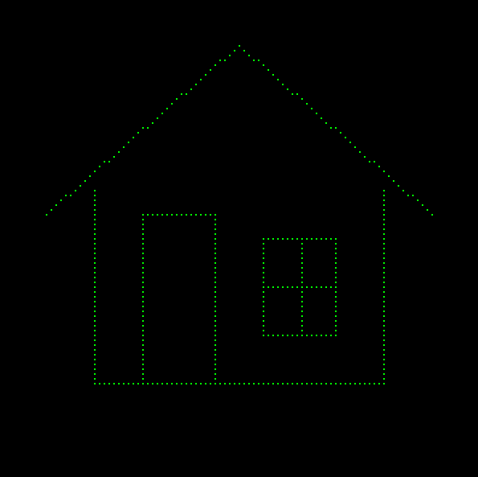

Lab Report Format
Note: The report must have a cover page with the title, necessary details of the course, course teacher and student submitting the report. If any similarities between two reports are observed then both of the reports won't be evaluated.

The lab report must contain the following,
Title: Implementation of Bresenham's Line Drawing Algorithm Using OpenGL
1. Introduction
Provide an overview of the topic covered in the report. Mention any preliminary setups or environment configurations you needed to perform before starting the tasks.

2. Problem Statement
Describe the task which you are solving here. Basically what was asked to do in the task.
If you want to include your homeworks, additional tasks that you have done while practicing, then you can include them too. It will be much appreciated as long as it's your original work and not a copy.
Each task should have separate problem statements and then source code and screenshot of the output.
Note: Difference between Introduction and problem statement is, Suppose you are implementing DDA Line Drawing algorithm. So your Introduction should be about Line drawing algorithms and the preliminary set up for implementing that and the problem statement should be about the specific problem you are solving which is implementing the DDA algorithm.

3. Source Code
Present your solution through the source code.
After the source code, include a short description explaining your strategy how you solved the task / what changes you made.

4. Output
Provide screenshots of the terminal showing the output.

5. Graph
Plot the vertices in a graph paper and draw the output by hand.

6. Discussion
- Reflect on what you have learnt from the task. Basically write your understanding.
- Mention any challenges or issues you faced while solving the task.

